1. What is the command to change directory and how to move one directory back?

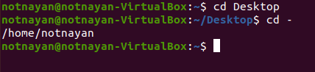

* cd to change directory
* cd – to move one directory back

1. What is the command to make directory named IPHONE and IPAD and remove the directory named IPAD?

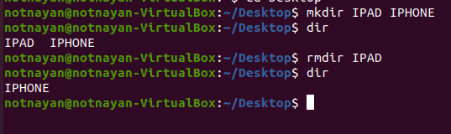

1. Make a directory name TextDocuments in the desktop and make 3 text files: **textfile1.txt, textfile2.txt and textfile3.txt** inside the TextDocument.



1. Remove the directory TextDocuments and contents within it.

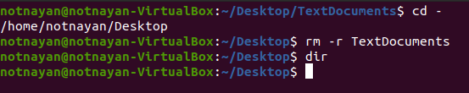

1. What is the command to list all the invisible files and to display the directories in detail?
   1. ls –a
   2. ls –l
   3. ls -al
2. How to remove the commands from screen without closing the terminal?

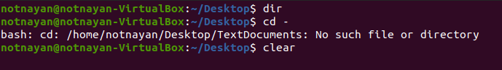

clear

1. Which command is used to find out the path of the current working directory (folder) you’re in?



pwd

1. What is the command to check which directory are you currently working on?



pwd

1. What is the difference between?
   1. cd ..

To navigate to previous directory

* 1. cd

To go to home directory

* 1. cd –

It contains the old pwd value

1. Create a file name name.txt on Desktop and add text “Hello, my name is John” into the file.

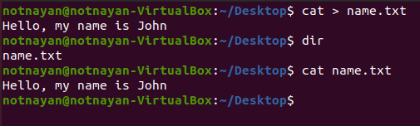

1. Copy new.txt from the current directory to a Document directory.

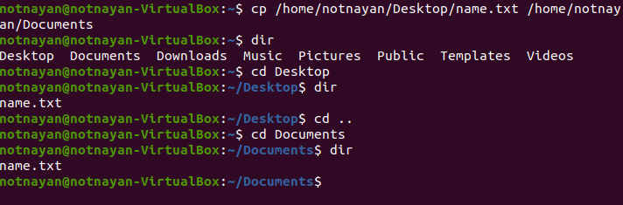

1. Compress the file “name.txt” into a zip archive.

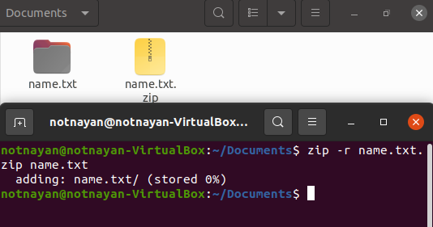

1. **df** is used to get the report of disk space uses on the system. The results shown is KBs. What if I want to see the report in megabytes?

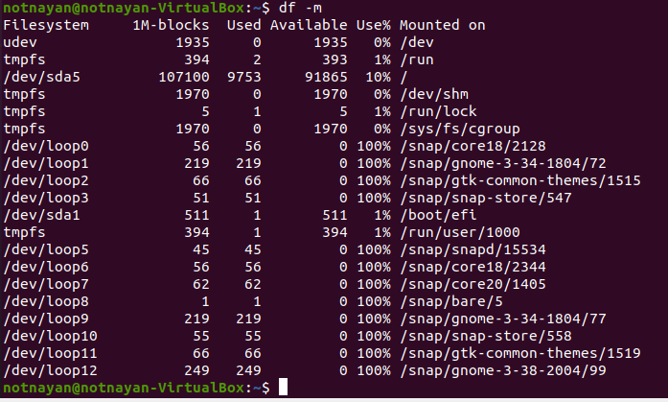

df -m — to display information of file system usage in MB.

1. What is the command to move file KAT.txt from directory Pictures to directory Videos if the full path of Pictures directory is /home/user/Pictures?

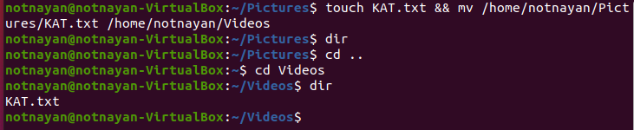

mv /home/notnayan/Pictures/KAT.txt /home/notnayan/Videos